Codes
See spreadsheet simple coding

cultural | interpersonal | personal
Designing for others | Navigation | Personal appropriation
Using funds of knowledge | Ideation
Community propagation | Division of labour
 | Technical processes

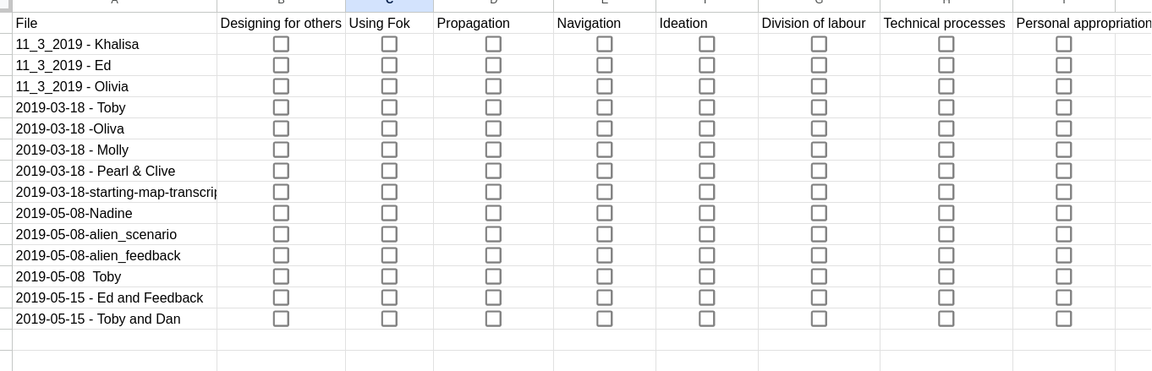

GDP usage in game making | Description (pitched to facilitators?) | Examples in data - see start of vignette for table
Personal appropriation:
GDPs used in appropriation of personal knowledge: e.g. CT, design and systems concepts | Facilitators can use existing and planned GDPs to surface computational, design and systems concepts embedded in games.  Facilitators should be cautious of overloading learners with shifting and competing goals. | Fluidity of operations (V1.3)-  Present in x out of y coded sessions.
Guided Participation / Interpersonal focus

GDPs as a framework for supporting resources and navigation | The restricted set of GDPs can serve as a framework for code examples and step-by-step tutorials. Presentation of documentation of GDP implementation as a menu or collection can facilitate flexibility of learner pathway and diversity of end design and without restricting access to resources beyond programme based support | Present in x out of y coded sessions.
GDPs used to scaffold ideation processes | GDP concepts can guide ideation processes in diverse ways including the use of visual code structures, and experimentation with core dynamics via rapid prototyping techniques. | Use of GDPs concepts by participants during ideation in Vignettes 2,3 & 7  Via visual prototyping in Vignettes 2 and 7  Discussion of GDP dynamics facilitated by template game structure in Vignettes …  Present in x out of y coded sessions.
GDPs used to aid the process of division of labour | Participants can split work and resolve working blockages by allocating different GDPs or parts thereof.  The use of GDP concepts as a lingua franca and the sometimes modular structure of GDPs help the division of labour as participants to divide work by working on different patterns or taking on project elements within patterns, sometimes building specialisms in the process. | Dividing work between pairs by pattern based on difficulty or aptitude. E.g. Vignette 3  Alternating between coding tasks by x in Vignette  Parents shifting from supportive role to a more directive at times e.g. Vignette 7  Present in x out of y coded sessions.
The role of GDP used emerging technical processes | The implementation of GDPs can stimulate participants to adopt or to share technical processes. | Debugging in Vignettes 2, 1,  Code patching and code snippets in Vignette 1  Present in x out of y coded sessions.
Cultural activity focus
GDPs can encourage learners to design for others | Referring to the impact of implementing or changing GDPs can help scaffold the process of imagining the end user experiences. | In Vignette 2 Suzanna (p) and Olive (c) show awareness of designing for others.  Present in 8 out of 12 coded sessions.
GDPs facilitate the use of wider funds of knowledge | Three dimensions of GDPs (mechanics, dynamics and aesthetics) can be used by participants to share and explore funds of knowledge and interest within the emerging learning community. | Dan’s enthusiasm for coding in Vignette 7.  Bertie’s sharing of knowledge of game mechanics in Vignette 1 (part two)  Present in x out of y coded sessions.
GDPs are propagated into the community through playtesting | The implementation of popular or novel GDPs by participant pairs or individuals is often spread through peer activity. | Toby’s focus on level building becomes a subject of community activity Vignette 1  Present in x out of y coded sessions.

Participants use of Game Design Patterns (GDPs) from thematic analysis of video data

GDPs facilitate learners to design for others
GDP concepts and language used in informal feedback for peers to influence modification of games
GDPs are propagated into the community through playtesting
GDPs facilitate the use of wider funds of knowledge from home and hobby settings

GDPs can assist project navigation, acting as a framework for code examples and step-by-step tutorials
GDPs can scaffold the ideation processes
GDPs aid the process of division of labour
GDP concepts are used in emerging technical processes

GDPs in the personal appropriation of concepts and processes

Early 2024 Versions

GDP usage in game making | Description | Examples
Guided Participation: GDPs offer the potential to assist project navigation
GDPs as a framework for navigation | GDPs can encourage and facilitate navigation of documentation and resources beyond programme based support  GDPs help learners navigation acting as a framework for code examples and step-by-step tutorials | The process of choice, use of documentation to support implementation and testing pivots on the design pattern and its behaviour.
Guided Participation: GDPs used to scaffold ideation processes
GDPs used to scaffold ideation processes | GDPs are used in a variety of ways to guide the ideation process via restriction of choice in pattern collection, starting template includes core dynamics, visual code structures of GDPs suit rapid prototyping. | GDPs are mentioned by name and via verbal and physical descriptions as a lingua franca and as shortcuts by participants when prioritising work
GDPs facilitate the use of wider funds of knowledge | GDPs allow participants to share and explore their home and professional funds of knowledge and practices in the emerging learning community.  Parents can share technical knowledge if they have it. | Parent comment from interview: “I love, I love, I love programming. I'm no good at pencils and pens drawing or anything like that. But writing software is the closest I get to a creative outlet.”  Child comments while playtesting: “It’s like parcours in Minecraft but timed. It’s like playing the game Wipeout. Have you ever played Wipeout?”
GDPs as used by participants in their prioritisation in the ideation process

Guided Participation: GDPs aiding the process of division of labour

GDPs used to scaffold ideation processes | GDPs are used in a variety of ways to guide the ideation process via restriction of choice in pattern collection, starting template includes core dynamics, visual code structures of GDPs suit rapid prototyping. | GDPs are mentioned by name and via verbal and physical descriptions as a lingua franca and as shortcuts by participants when prioritising work
GDPs used to aid the process of division of labour | Participants can split work and resolve working blockages by allocating different GDPs or parts thereof. | GDPs come in varied levels of coding difficulty which help in dividing work between pairs. Some families alternate between coding, and parents sometimes shift from taking a supportive role to a more directive one for difficult patterns.
GDPs can encourage learners to design for others | Referring to GDPs (especially during playtesting) can help scaffold the process of imagining the end user experiences.  GDPs aid the overall process of design for others by providing discreet and clear goals which are nested in the wider goal of making an engaging game. | Child: You seem to not give up. that’s good  Peer Adult: I got to your level  Child: Good! (laughs)  Child: It’s a secret, special one. (...) If people tried hard they would get to my level.
Guided Participation: The role of GDP used in emerging technical processes
GDPs used to explore computational, design and systems concepts | Facilitators can use existing and planned GDPs to surface computational, design and systems concepts embedded in games. | Facilitators should be cautious of overloading learners with shifting and competing goals
Personal appropriation: The role of GDPs in the personal appropriation of computational, design and systems concepts
General observations |  | Link to review of personal knowledge in Kafai.

